Synopsis

Air Quality Level Classification System Using Machine Learning
Problem Id:

Student Name: Devesh Saini
University Roll number:2028706
Section: P

Student Name: Harshita Joshi
University Roll number:2028427
Section: P

Student Name: Anmol Gupta
University Roll number:2028644
Section: P

- Problem Description:
Air pollution is a critical environmental issue affecting human health and ecosystems. Monitoring and predicting air quality levels is essential for taking preventive actions and ensuring public safety. However, raw sensor data alone does not provide meaningful insights without proper analysis.
This project aims to develop an Air Quality Level Classification System using machine learning techniques in Python. The system uses environmental sensor data such as CO (Carbon Monoxide), NO₂ (Nitrogen Dioxide), temperature, and humidity to classify air quality into categories like Good, Moderate, and Poor.
By applying data preprocessing, feature selection, and classification algorithms, the model can identify patterns in pollution data and provide accurate predictions. This system can help in environmental monitoring and decision-making for better air quality management.
- Steps of Implementation:
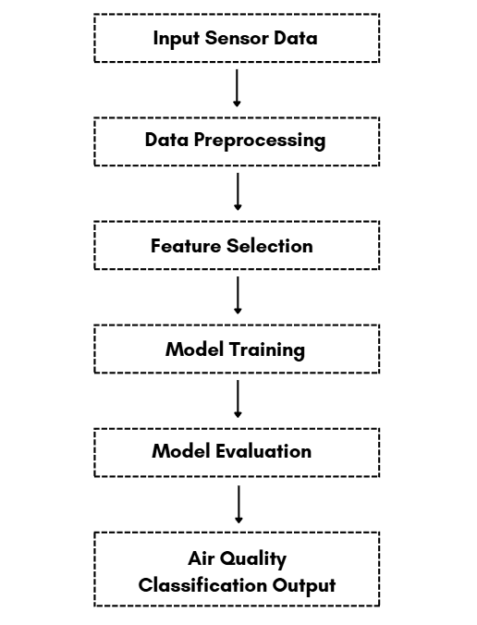
- Expected Modules/ Libraries to be used :
- NumPy – Numerical computations and array operations
- Pandas – Data handling and preprocessing
- Matplotlib – Data visualization
- Seaborn – Statistical data visualization
- Scikit-learn (sklearn) – Machine learning models and tools
- StandardScaler – Feature scaling and normalization
- KNeighborsClassifier – KNN classification algorithm
- LogisticRegression – Classification model

- Expected Evaluation metrics and Plots to be used:
Evaluation Metrics
- Accuracy – Overall correctness of predictions
- Precision – Correctness of positive predictions
- Recall – Ability to detect actual positive cases
- F1 Score – Balance between precision and recall
- Confusion Matrix – Detailed performance evaluation
Visualization Plots
- Confusion Matrix Heatmap
- Correlation Heatmap
- Scatter Plots
- Histogram / Distribution Plots
- Required topics from the subject:
- Python Basics: Variables, data types, and operators used in ML implementation
- NumPy & Arrays: Efficient numerical computation and data handling
- Pandas DataFrames: Data manipulation, cleaning, and preprocessing
- Data Visualization: Graphical representation using Matplotlib and Seaborn
- Machine Learning Concepts: Supervised learning, classification, and model evaluation
Platform Required:
Visual studio/ jupyter notebook
- Books and Link Sources:
- Hands-On Machine Learning with Scikit-Learn & TensorFlow – Aurélien Géron
- Introduction to Machine Learning with Python – Andreas Müller
- Scikit-learn Documentation – https://scikit-learn.org
- Kaggle (Datasets & Tutorials) – https://www.kaggle.com
- Python Documentation – https://docs.python.org
Prompt Used for Dataset Generation:
“Generate a dataset with 1 Lakh rows for an Air Quality Classification system. The dataset should include the following columns: CO, NO₂, Temperature, Humidity, and Air_Quality .
Ensure the dataset reflects realistic environments:
- Random noise in sensor readings
- Missing (null) values in some entries
- Outliers (extreme or abnormal values)
- Slight inconsistencies or variability in measurements

